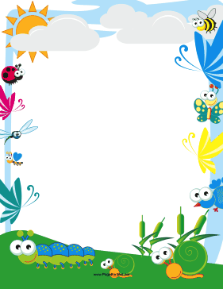
Bug'n Roll

Dum diddy diddy doo
Dum diddy dum
Dum diddy diddy doo
Dum diddy dum
Oo-oo-oo!
Bug'n Roll!

The ants in the grass all
march, march, march.
March!
March, march, march.
March, march, march.
The ants in the grass all
march, march, march.
March!
All day long.

The bees around the flowers all
buzz, buzz, buzz.
Buzz!
Buzz, buzz, buzz.
Buzz, buzz, buzz.
The bees around the flowers all
buzz, buzz, buzz.
Buzz!
All day long.

Oo-oo-oo!
Bug'n Roll!

The fireflies at night all
blink, blink, blink.
Blink!
Blink, blink, blink.
Blink, blink, blink.
The fireflies at night all
blink, blink, blink.
Blink!
All night long.

The caterpilllars in the field all
creep, creep, creep.
Creep!
Creep, creep, creep.
Creep, creep, creep.
The catrepillars in the field all
creep, creep, creep.
Creep!
All day long.

Dum diddy diddy doo
Dum diddy dum
Yeah!

